**ML Algorithms**

Regression 🡪 Linear Regression

Polynomial Linear Regression

Multiple Linear Regression

**1. Linear Regression: Where the output column is numerical.**

Simple Linear Regression is where,

CGPA |||||||||| Package

6.66 |||||||||||||| 3.01

**Make a ml model where we can predict package from cgpa.**

Here we plot the cgpa vs package. And we try to understand if it’s somewhat linear. Real world data is never linear.

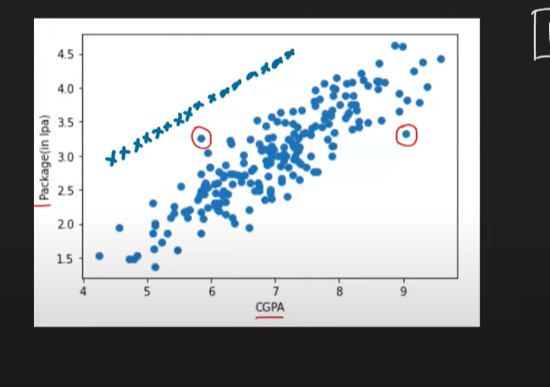  
If it was completely linear, and find the equation of that line. (y=mx+b), our model will just plot it on the line and find package. So, even for linear regression, we will draw a line known as best fit line. Because this line crosses all points at a minimum distance.

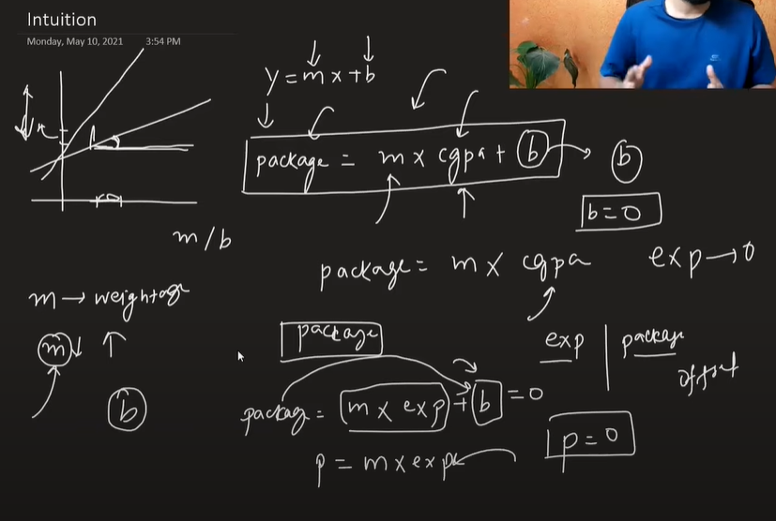

In linear regression, we find out the m and b . To fine the m and b there are two ways we can approach the solution. First of all, the Closed Formula (no ddx or integration) and open form meaning no Non closed Formula.